Report: Nanocomposites By: Joshua Jongema
Introduction
“A nanocomposite is a multiphase solid material where one of the phases has one,
two or three dimensions of less than 100 nanometers.”¹
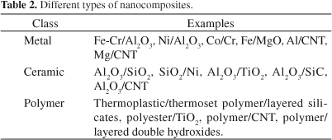
Table above – Types of nanocomposites²
Nanocomposites in literature date back to 1961, when Blumstein first used the term. His studies in 1965 outlined methods to improve the thermal stability of polymethyl-methacrylate-layered silicate nanocomposites.³ Since that time, they have been designed for use in construction, automotive, electronics and semiconductor, aviation and aerospace, health and biotechnology, and other industries. Many nanocomposite materials find suitable uses in a wide range of applications across different industries.
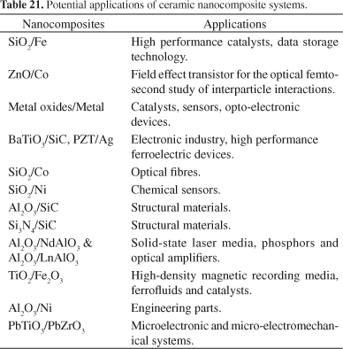
Table above – Nanocomposites and their possible applications²
There are three major types of nanocomposites. First there are ceramic matrix nanocomposites (CMNC). One example is Al2O3/SiC. These overcome the limitations that traditional brittle ceramics pose for industry, providing increased fracture toughness.²
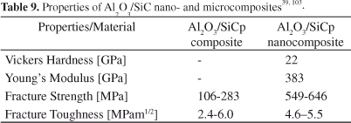
Table above – Properties of conventional composite vs nanocomposite²
Then there is metal matrix nanocomposites (MMNC). These materials provide high strength and modulus, and toughness, combining metal and ceramic features. These are used in the aerospace and automotive industries.
Lastly there are polymer-based nanocomposites, which can be lightweight and ductile, though with a low modulus and strength relative to other nanocomposites. These materials see polymers filled with fibers, whiskers, platelets or particles to increase flame retardancy, strength and impact resistance.²
“Polymer Nanocomposites are materials in which inorganic (nanoparticles are)… dispersed in an organic polymer matrix such as polyacetylene, poly thiophene, and polypyrrole.”¹

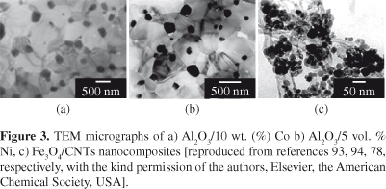
Figures above – TEM graphs of CMNC - and below – TEM images of polymer based nanocomposite²
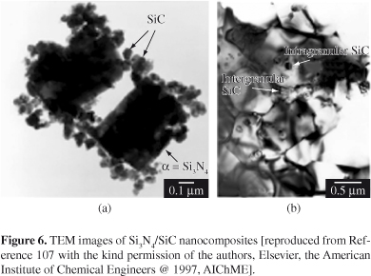

Companies and Their Products
As early as 1999, the US company RTP had produced their first clay/polyamide nanocomposite, which made lighter parts with greater impact resistance. Since that time over 100 companies, government agencies and academic institutions worldwide have done work in this field. The main producers of nanoclay are Southern Clay and Nanocor, but other companies such as DSM, LG Chemicals, Bayer, BASF, Rhodia, Degussa Huls, Dow and Ube Industries have also jumped on board.⁴
eSpin fabricates synthetic polymer, biological, carbon and ceramic nanofibers, which are being considered for many uses including filtration for many uses including the automotive industry.⁵
“eSpin's nanofibers are 20-200nm in diameter, have a very high surface area to mass ratio, and can be formed into membranes with very high porosity.”⁶
Cabot Corporation touts a high-quality silica aerogel, for use in energy-efficient buildings, surfaces and personal care products, among others. A great insulating solid material, aerogel can increase the energy savings of materials and products and give high-performance coatings to personal care products. Examples include interior and exterior insulating plasters, daylighting panels and tensile roofing systems, ultra-low gloss matte paint, outdoor gear and apparel, and skin and beauty care products.⁷
Elementis Specialties has a wide array of nanocomposites available including Bentone LT, which is described as a hectorite clay which has been organically modified, and is used in the water phase of cremes, lotions, deodorants and other cosmetics, to provide high efficiency thickening and to give higher viscosity than the competition. It is composed of hectorite and hydroxyethylcellulose.⁸
3M has created nanocomposite dental fillings, composed of dimethacrylate polymer filled with silica and zirconia nanoclusters, called Filtek Z250XT Nano Hybrid Universal Restorative. These can come in 12 shades to match all teeth types, is easier to sculpt and handle, provides higher strength and wear resistance, are easy to polish and have improved polish retention.⁹
DSM produces melamine-based flame retardants. For example, Stanyl is one for use in high-temperature electronic systems and components including connectors, sockets and others. DSM has many nanocomposite materials which are halogen-free, to avoid corrosion during extrusion.¹⁰
Zyvex Technologies created Arovex HT, which advances on their first design to bring a second-generation carbon nanotube, with doubled fracture toughness. These have found use in carbon-fiber lacrosse shafts, and have been reported as providing increased performance, durability and temperature resistance.¹¹
“Zyvex Technologies was founded in 1997 as the world's first molecular carbon nanotechnology company and is the first to commercialize products using carbon nanomaterials.”¹¹
Nanocor has developed a series of materials for packaging, including Nylon MXD6, which they market under the product name Imperm 103 and 105. It has been cleared for use in multilayer bottles such as beer and juices and has improved the weight and capacity of MREs used by the military. Imperm is shown to improve oxygen and CO2 barrier, shelf life, decrease weight.¹²
EU’s NANOCORE Project has developed a foam core material with high mechanical performance, which will be used in ferries and cruise ships. Spurned by SOLAS and EU REACH legislation, NANOCORE has brought forth a modified nanocomposite foam core material with a non-toxic flame-retardant ability, with increased strength, toughness and stiffness.¹³

How Nanocomposites are Fabricated:
Nanocomposites can be created using solvent-assisted methods, melt homogenization and in situ polymerization, with melting used more often. Difficulties plague nanocomposite production, including dispersion and homogeneity, and improper adhesion. Regardless, they have found applications in niche areas of interest.³
Ceramic Matrix Nanocomposites can be created using the conventional powder method, polymer precursor route, physical or chemical vapor deposition, spray pyrolysis and other chemical methods, including template synthesis, sol-gel processing, and colloidal and precipitation approaches.²
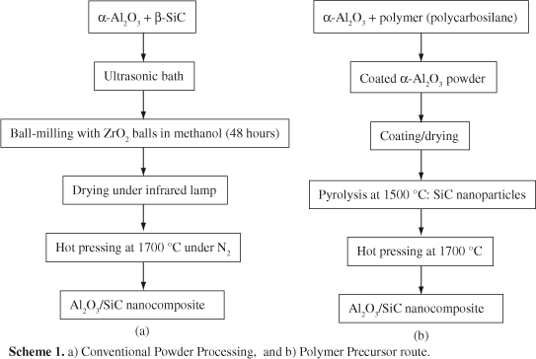
Scheme above – Conventional Powder Processing vs Polymer Precursor route²
Metal Matrix Nanocomposites are typically produced using rapid solidification, spray pyrolysis, physical or chemical vapor deposition, liquid metal infiltration, rapid solidification, electrodeposition and other chemical methods including sol-gel and colloidal processes.²

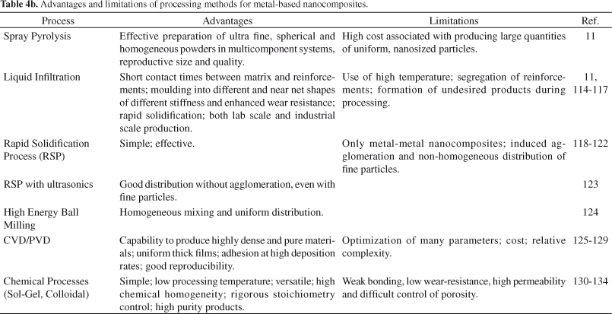
Table above – Pros and Cons of MBNC methods of processing²
Polymer Matrix Nanocomposites have been fabricated using sol-gel processing, in-situ polymerization, direct mixture, template synthesis, in-situ intercalative polymerization, intercalation of polymer or pre-polymer from solution, and melt intercalation (shown below)²

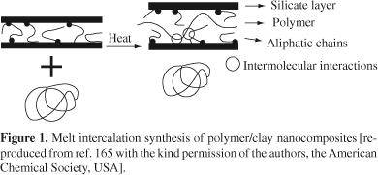
Figure above – Process of intercalation during the synthesis of polymer/clay nanocomposites.²
Clay Nanocomposites have been produced by Nanocor, Inc. Nanocor summarizes the preparation of their nanocomposites as including the dispersion of their “Nanomer” nanoclay at 5 percent weight with a host polymer, through a process called exfoliation.¹⁴
“Clays are naturally occurring layered aluminosilicates plates stacked together.”¹⁵

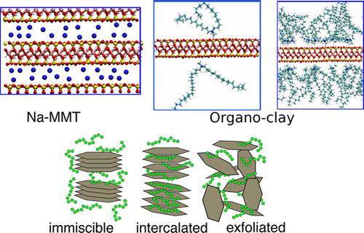
Figure above: Top-left: Na-montmorillonite, Top-right: alkali ions give clay hydrophobicity, Bottom: immiscible when clay is left aggregated, intercalated if clay interlayer penetrated, or exfoliated if layers fully disperse.¹⁶
The exfoliation method has used a montmorillonite clay, a quaternary ammonium dimethyldioctadecylammonium ionic surfactant, and hydrophilic polyethylene glycol, to produce exfoliated clay layers. Some use a solution method, but here a melt process was used at 500K and 300 atm). It was found that exfoliated morphologies greatly enhance a composite’s elastic properties.¹⁷
Graphene is produced using four main methods, which are sol-gel, in situ growth, hydrothermal and/or solvothermal, and solution mixing methods. In sol-gel processing, a sol is obtained using metallic alkoxides or organometallic precursors such as tetrabutyl titanate dispersed in graphene-containing absolute ethanol solution, which gradually forms a sol with continuous magnetic stirring. Afterwards drying and post-heat treatment form TiO2/graphene nanocomposites.¹⁷
Hectorite is part of a group of phyllosilicate minerals called smectite clays, which are characterized by an octahedral layer (Al, Mg, Fe, O and OH) sandwiched between two silica tetrahedral (SiO4) layers. Synthetic hectorite has been produced which have good reproducibility, higher purity and better composition, and the pore size distribution can be controlled.¹⁸
“Hectorite has been synthesized by aging the gel precursor by microwave–hydrothermal treatment at 393 K for 16 h. This hectorite had higher purity (60%) than hectorite prepared by conventional heating (45%).”¹⁹
“Hydrothermal reaction of slurries made from homogeneous Si-Mg precipitates, lithium hydroxide and sodium hydroxide yielded hectorite-like smectite products.”²⁰
Aerogel can be most effectively created using a supercritical drying process at high temperatures and pressures. Aerogel can also be created using a milling process of crushing, or from the bottom up using aerosol and sol-gel processes, and precipitation reactions. Many aerogels are made using the sol-gel process, which involves nanoparticles agglomerating in liquid to form a continuous 3D network throughout.²¹
“The aerogel production can be characterized by a series of distinct steps as follows…
Step 1: Formation of different stable solutions of the alkoxide or solvated metal precursor (sol).
Step 2: Gelation resulting from the formation of an oxide- or alcohol- bridged network (gel) by a polycondensation or polyesterification reactions that result in a dramatic increase in the viscosity of the solution.
Step 3: Aging of gel (syneresis), during which the polycondensation reactions continue until the gel transforms into a solid mass, accompanied by contraction of the gel network and expulsion of solvent from gel pores. Ostwald ripening (the phenomenon by which smaller particles are consumed by larger particles during the growth process) and phase transformations may occur concurrently with syneresis. The aging process of gels is critical to the prevention of cracks in gels that have been cast.
Step 4: Shaping of gel into the desired form or shape followed by drying. In this step solvent is removed.”²¹

Melamine-based Flame Retardants are produced using a byproduct of melamine called melam. Melam is typically produced by the heating of melamine or its salts to temperatures at roughly 300 degrees Celsius. It has also been produced through the heat treatment of melamine in the presence of an acid such as toluene sulfonic acid. DSM reported the use of 7% melam as a flame retardant in three of their nanocomposites, PA 6, PA 66 and PA 46.²²
Conclusion
The global market for nanocomposites is expected to rise to roughly 7500 million by 2022. There is an increasing demand for electronics that have nanocomposite properties such as conductivity and thermal resistance. Other nanocomposites have high tensile strength, better resistance to corrosion, optical and magnetic properties, and thermal and electronic conductivity. Other industries expecting to see growth related to nanocomposites include building and construction, energy, packaging, automotive, electronics and IT. A lack of development and high costs involved in production is expected to hamper growth for some time, but advancements in production optimization are expected to be key in sustaining growth.²³

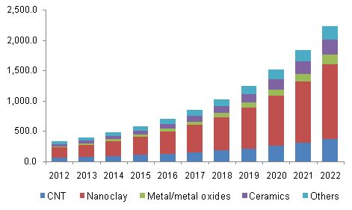
Graph above – Values projected in between 2012-2022 for various nanocomposites²³

Sources:
(1) Polymer Nanocomposites and their Applications in Electronics Industry, (Tyagi, Tyagi), International Journal of Electronics and Electrical Engineering Vol 7 # 6 (2014) pp. 603-608, https://www.ripublication.com/irph/ijeee_spl/ijeeev7n6_10.pdf
(2) Nanocomposites: synthesis, structure, properties and new application opportunities, (Camargo, Satyanarayana, Wypych), Materials Research vol. 12 #1 (Jan/Mar 2009), http://www.scielo.br/scielo.php?script=sci_arttext&pid=S1516-14392009000100002
(3) https://www.sciencedirect.com/topics/chemistry/nanocomposites
(4) Plastic Films – Situation and Outlook (Pardos), (Aug 2004), Rapra Technology Limited, (https://books.google.com/books?id=pvz4MVzv-98C&pg=PA62&lpg=PA62&dq=dsm+company+nanocomposite&source=bl&ots=bboqR_3yj5&sig=7_n86xxJh3-fDf7K2NCn5sd89J0&hl=en&sa=X&ved=0ahUKEwi5wa_z-tbZAhUE9YMKHZzJBzoQ6AEIVDAE#v=onepage&q=dsm%20company%20nanocomposite&f=false)
(5) http://www.espintechnologies.com/about/about-nanofibers.html
(6) https://www.internano.org/node/819
(7) http://www.cabotcorp.com/solutions/products-plus/aerogel
(8) http://elementis-specialties.com/esweb/webproducts.nsf/allbydocid/ADDA001A67EC5F6F8525760000564BC1/$FILE/PDS-BENTONE%C2%AE%20LT.pdf
(9) http://solutions.3mae.ae/wps/portal/3M/en_AE/3M_ESPE/Dental-Manufacturers/Products/Dental-Restorative-Materials/Dental-Composites/Nano-Hybridcomposite/
(10) https://www.dsm.com/products/stanyl/en_US/press-releases/2012/10/2012-10-29-dsm-launches-new-halogen-free-flame-retardant-stanyl-products-for-electronics-market.html
(11) https://www.nanowerk.com/nanotechnology-news/newsid=34169.php (Jan 2014)
(12) http://www.nanocor.com/tech_papers/antec-nanocor-tie%20lan-5-07.pdf
(13) https://cordis.europa.eu/result/rcn/144518_en.html
(14) http://www.nanocor.com/nanocomposites.asp
(15) Clay-Semiconductor Nanocomposites for Photocatalytic Applications (Feb 2017) (Praneeth, Paria), from book Clay Minerals: Properties, Occurrence and Uses, Chapter 5, Nova Science Publishers, Inc. https://www.researchgate.net/profile/Santanu_Paria/publication/311845136_Clay-Semiconductor_Nanocomposites_for_Photocatalytic_Applications/links/58e4db89a6fdcc6800ae1e3d/Clay-Semiconductor-Nanocomposites-for-Photocatalytic-Applications.pdf
(16) Mechanism of Exfoliation and Prediction of Materials Properties of Clay-Polymer Nanocomposites from Multiscale Modeling, (Suter, Groen, Coveney), (Nov 2015), Centre for Computational Science, University College London, https://pubs.acs.org/doi/full/10.1021/acs.nanolett.5b03547
(17) Nanocomposites – New Trends and Developments, pp.243, (Zhang, Cui), https://cdn.intechopen.com/pdfs-wm/38720.pdf
(18) Ph. D. Thesis, Ghanshyam V. Joshi, Ch 4: Synthesis and Characterization of Hectorite and its use as Drug Deliver Carrier, http://shodhganga.inflibnet.ac.in/bitstream/10603/9166/8/08_chapter%204.pdf
(19) Fast Microwave Synthesis of Hectorite, (Vicente, Salagre, Cesteros, Guirado, Medina, Sueiras) Applied Clay Science (Journal), Vol. 43 Issue 1, January 2009, pp. 103-107, https://www.sciencedirect.com/science/article/pii/S0169131708001518
(20) Synthesis of Hectorite, (Torii, Iwasaki), Clay Science (Journal), Vol 7 Issue 1, pp. 1-16, https://www.jstage.jst.go.jp/article/jcssjclayscience1960/7/1/7_1_1/_article
(21) https://ac.els-cdn.com/S1877705813007583/1-s2.0-S1877705813007583-main.pdf?_tid=d1055ce1-527e-4048-ac2a-fb4d23631057&acdnat=1520337057_4e6c690a168a6d452f38c69c29bb496b
(22) Non-Halogenated Flame Retardant Handbook (Morgan, Wilkie), Scrivener Publishing, section 4.4.5, https://books.google.com/books?id=LJNSAwAAQBAJ&pg=PT128&lpg=PT128&dq=dsm+melamine+based+flame+retardants+synthesis&source=bl&ots=VV07zqaZ5P&sig=NhJ-jMcFNw0Nbg3_hzbhjw1boM4&hl=en&sa=X&ved=0ahUKEwjPz4C3jNfZAhUM74MKHQaPAegQ6AEISDAD#v=onepage&q=dsm%20melamine%20based%20flame%20retardants%20synthesis&f=false
(23) https://www.grandviewresearch.com/industry-analysis/nanocomposites-market

